Nombre________________
A presentational major
Create a poster that represents your point of view of the argument you had yesterday. The poster should have your points of view and use as many functional chunks and vocab as possible. It should also be colorful and creative. You may use white computer paper or construction paper that are located in the bins.
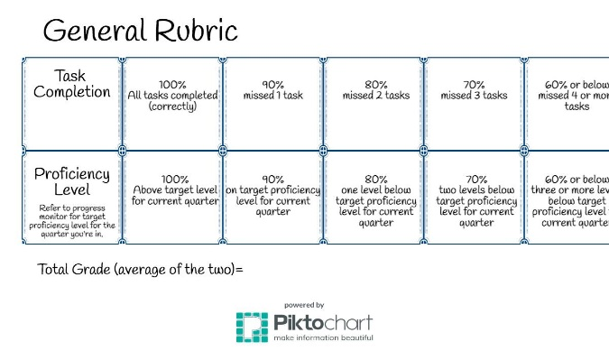

Nombre________________
A presentational major
Create a poster that represents your point of view of the argument you had yesterday. The poster should have your points of view and use as many functional chunks and vocab as possible. It should also be colorful and creative. You may use white computer paper or construction paper that are located in the bins.

