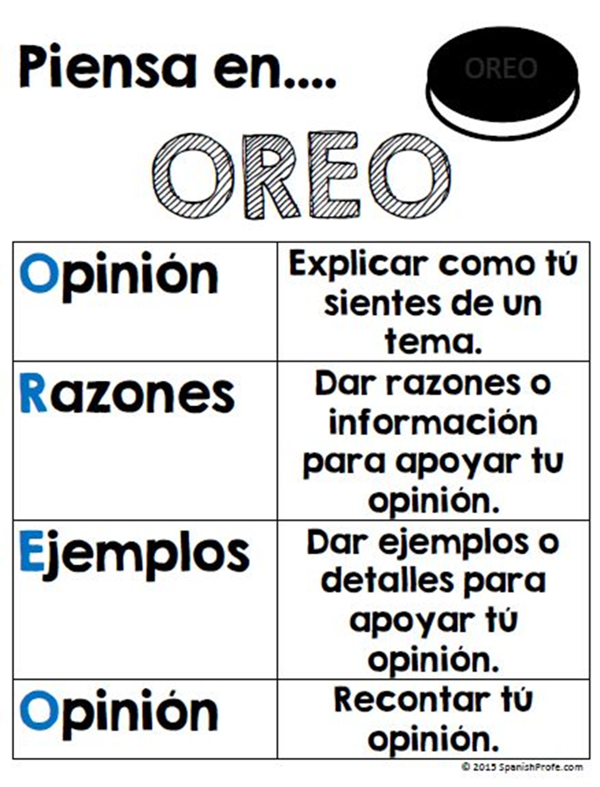
A Reading Practice 1
- What does each letter stand for?
- Rewrite this chart with a third column including what you would say in order to make your point on the topic you chose to argue about. Please make sure Sra. Bartlett approves and checks off your topic before you start?

