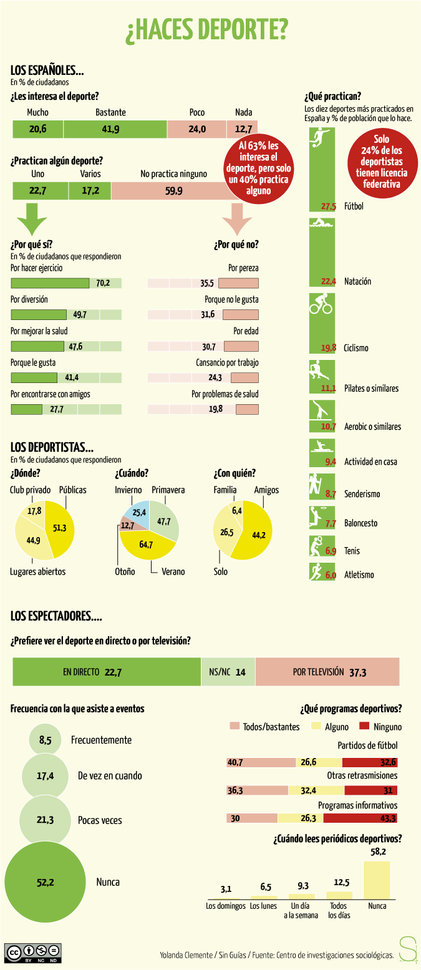

- What do you think this is a study of?
- What is the most interesting fact to you?
- What do you believe would be the difference between los españoles and los americanos?
- Are there any words you don’t know? Pick three and find their meaning by looking at the other information around it.
- When do Spanish speakers use commas versus decimals?

