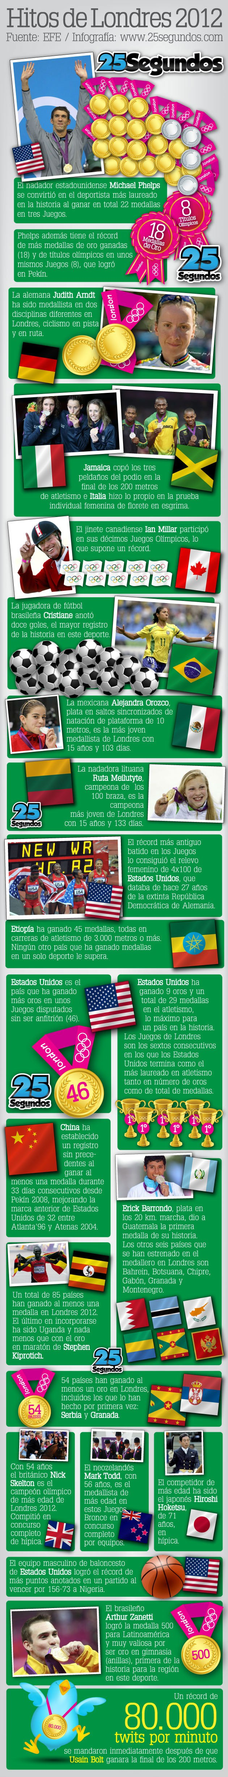

- What is the main idea?
- Please find three words you don’t know and using context clues, find their meaning. Did the pictures help?
- What is a “twit”?
- Who was your favorite and why?

