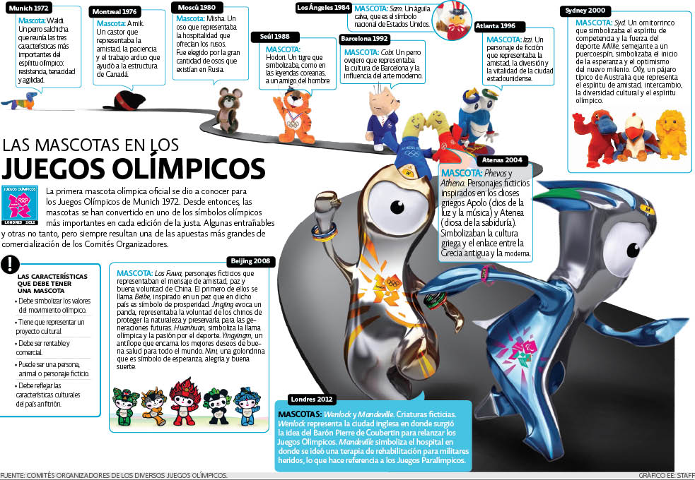
- There are two meaning for mascota. What are they?
- Pick three mascotas de los olímpicos, why are they important and what type of animal are they?
- What characteristics should a mascot have?
- What is the oldest mascot and what is the newest?

