Read the following article and answer the questions that follow. Do not glue this into your ISN and please answer the questions on the back of this paper or on a separate sheet of paper.
El arte en los Juegos Olímpicos
Redacción COMUNICA abril de 2016.- Cada cuatro veranos, la ciudad de Olimpia en la antigua Grecia convocaba a la celebración de apasionantes competencias deportivas que se llevaban a cabo en el mes de agosto durante cinco días.

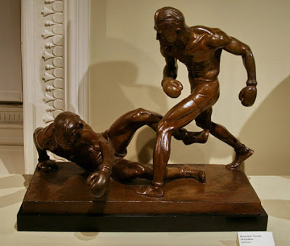Medalla de Oro en 1932 (escultura)

Key words: se llevaban- , a cabo-
- What are some cognates that you found and what do they mean?
- What is this a picture of?
- What do you remember about writing dates in Spanish?
- What is the main idea of this first segment of the article that you are reading?

Read the following article and answer the questions that follow. Do not glue this into your ISN and please answer the questions on the back of this paper or on a separate sheet of paper.
El arte en los Juegos Olímpicos
Redacción COMUNICA abril de 2016.- Cada cuatro veranos, la ciudad de Olimpia en la antigua Grecia convocaba a la celebración de apasionantes competencias deportivas que se llevaban a cabo en el mes de agosto durante cinco días.

Medalla de Oro en 1932 (escultura)

Key words: se llevaban- , a cabo-
- What are some cognates that you found and what do they mean?
- What is this a picture of?
- What do you remember about writing dates in Spanish?
- What is the main idea of this first segment of the article that you are reading?

