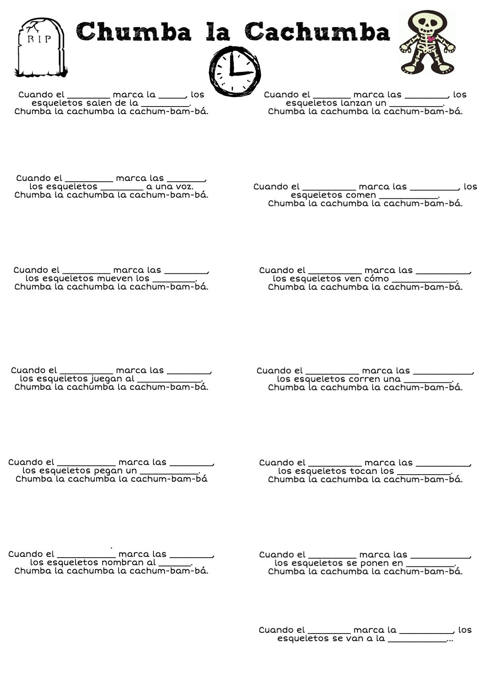

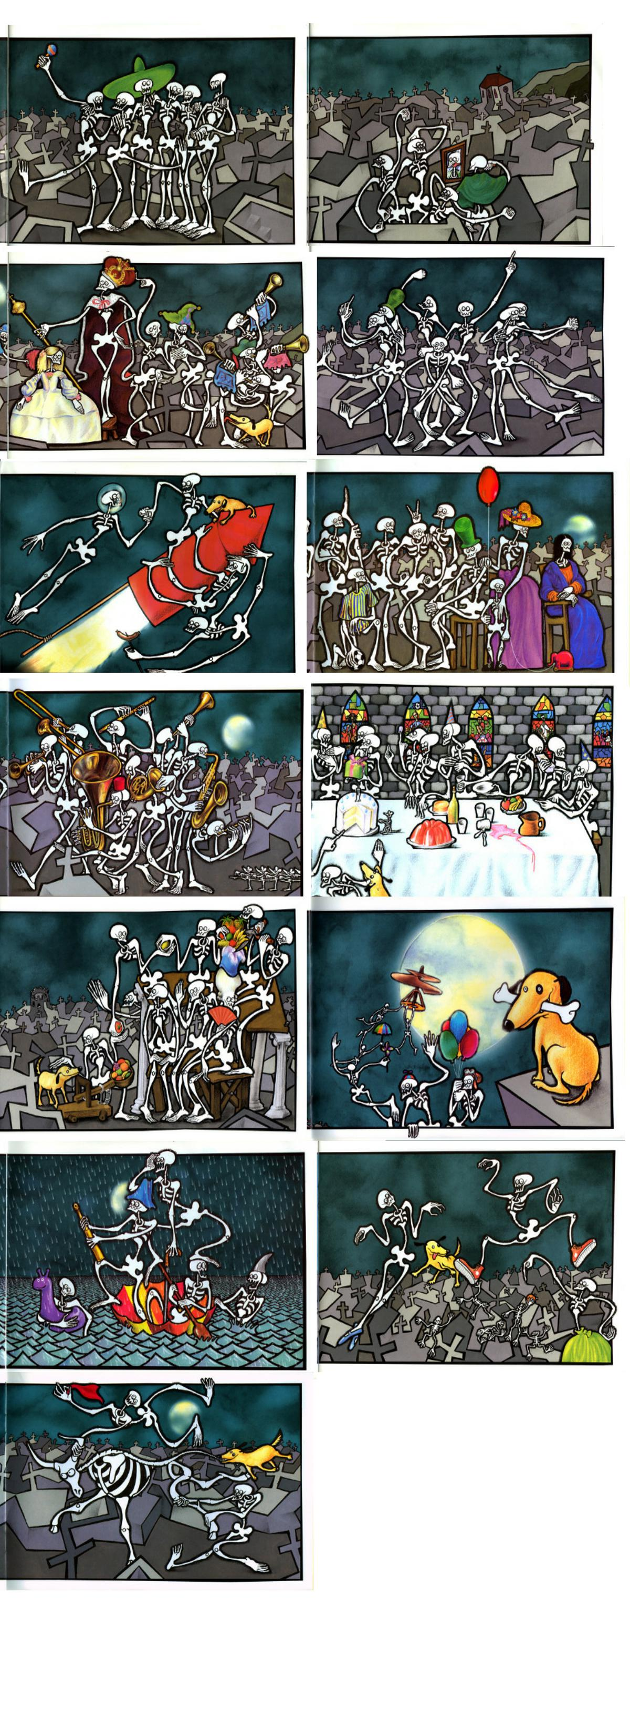

Instructions:

1. Glue the lyrics page on the right side of a new page in your ISN. While listening to the song, fill in the blanks on the song sheet.

2. Illustrate the underline words in the spot under the lyrics. For example, the first one the blanks are una and tumba, so you’ll draw a clock at one, and draw a tomb.

3. On the left side of your ISN you’re going to draw a large clock (leave room for pictures to be pasted around the clock, though. Then, cut out and glue the pictures that match the description for each time near that time on the clock. So the picture with skeletons leaving the tomb will go near one. You may need to space them out different and arrow out to the picture. NOTE: The pictures are not in order, so you’ll have to figure out which one to put where based on understanding the meaning of the song. You can watch the song again to also see which one goes where if you would like.

