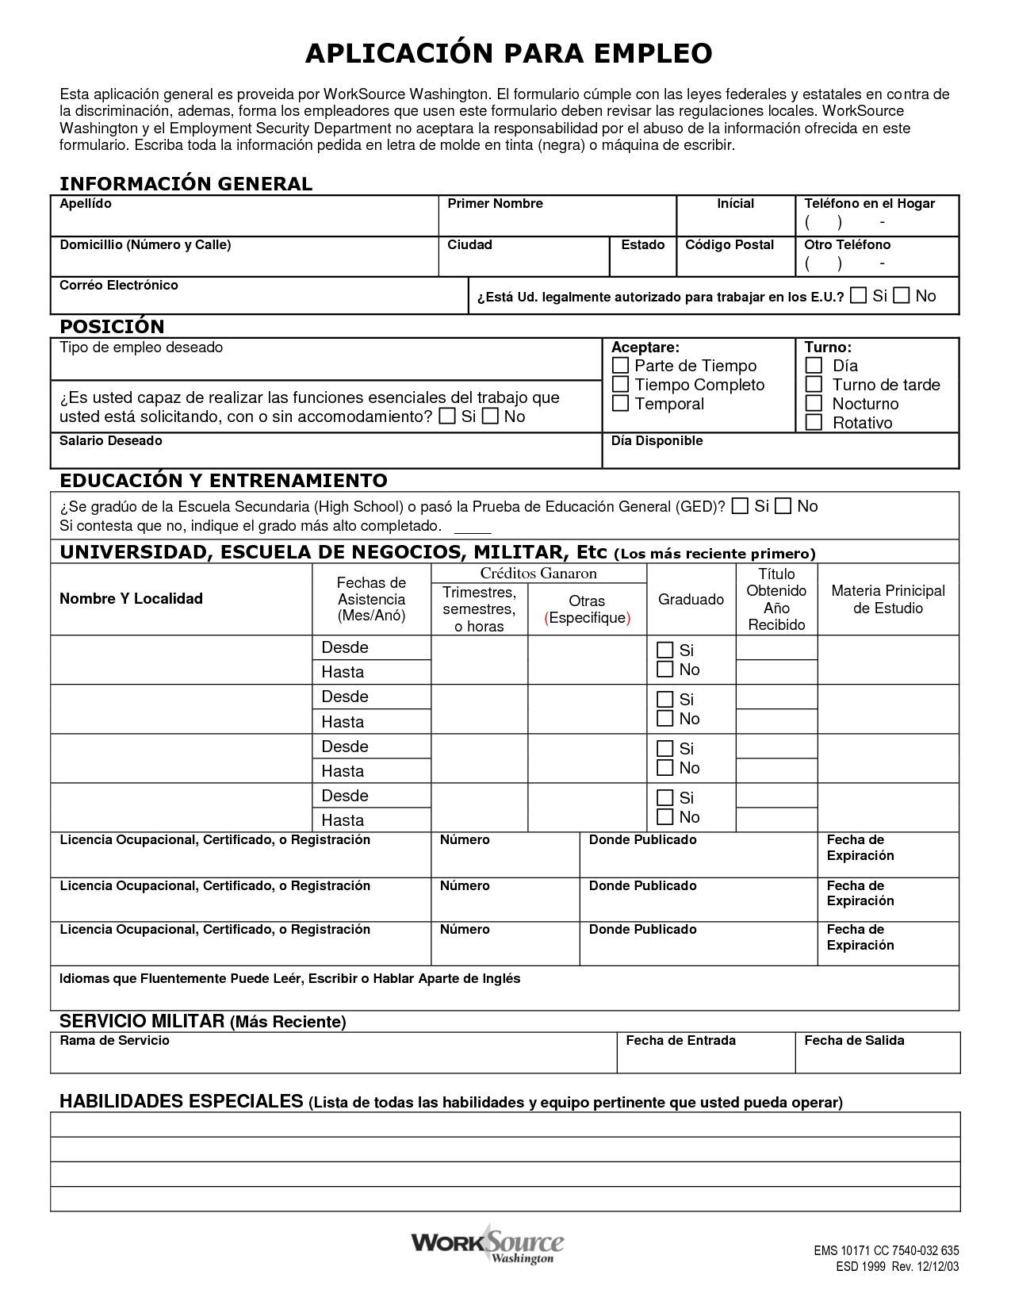

Key words: trabajar-to work,
- What is this an application for? What words give that away?
- Find 3 words you don’t know and, using context clues, figure out their meaning.
- Fill out as much information as you can on the form (real or fake information).
- Please look at number 4 that is labeled on the document. Based on context and keywords above, what do you think E.U. is?
- What do you think “habilidades especiales” means? Fill out yours, in English, on the form.

