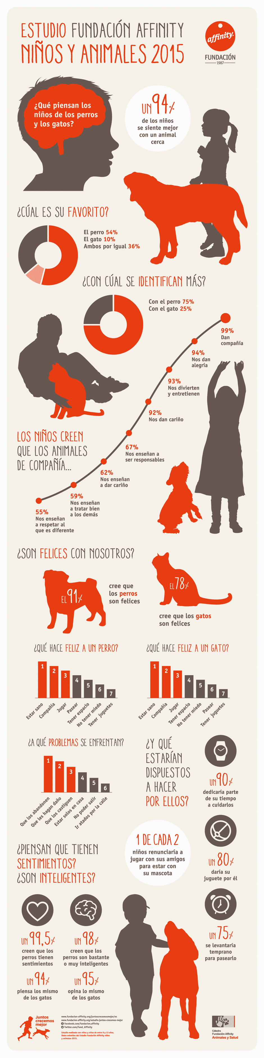

Vocabulario esencial: cerca-near, ambos-both, alegría-happiness, nos divierten-they have fun with us, cariño-lovable/cute , tratar bien a los demás-treat others well, estarían dispuestos-are we willing to do, daño-damage , lo mismo- the same
- What is the main idea of this infographic? Who is being studied for data purposes?
- What are some interrogatives (question words) that you found in Spanish and what do they mean in English?
- Se siente, cree(n) que, piensan que, hace are some important words that you have learned. Do you remember what they mean?
- What are sentimientos? How did you figure that out?
- ¿En conclusion, qué piensas tú sobre esta información? Answer in Spanish.

