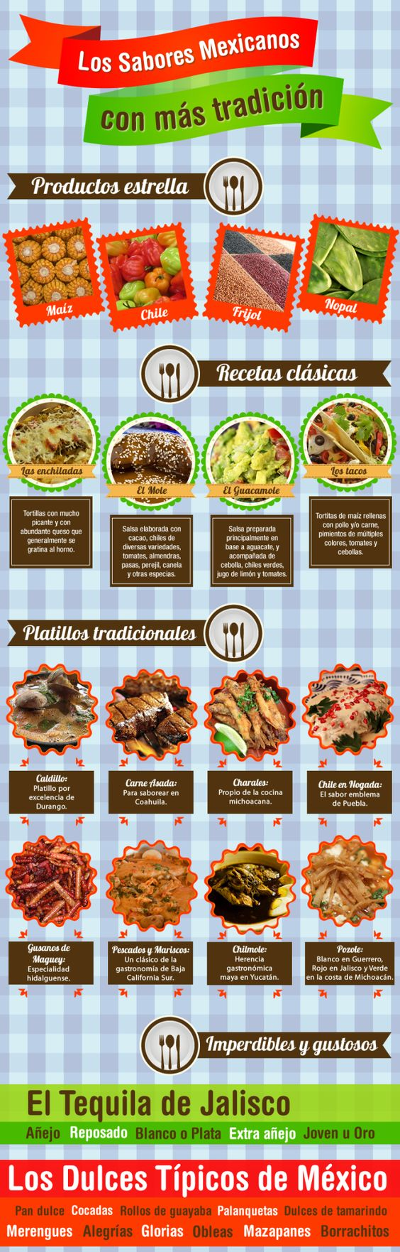

- What is the main idea? Why is the title of any reading important to figuring out the main idea?
- Choose 3 recipes in the “recetas clásicas” section and give me 2 adjectives that would describe them in Spanish.
- Where are each of the “platillos tradicionales” from? What is the word that comes before the place that means “from” or “of”?
- Please look these “platillos” up on your device and tell me which one seems the most interesting to you. How would you order this in a restaurant?
- Make a chart like this:
Diferencias:
Recetas Clásicas | Platillos Tradicionales | Imperdibles y gustosos

Similaridades:

Recetas Clásicas, Platillos Tradicionales, Imperdibles y gustosos

